RIFD-NET: A ROBUST IMAGE FORGERY DETECTION NETWORK
Abstract:
This project proposes RIFD-Net, a robust image forgery detection network designed to accurately detect spliced (forged) regions in noisy images. Traditional forgery detection methods lose accuracy when images contain noise, so RIFD-Net incorporates a multi-stage approach including noise detection, image de-noising using ADNET, and forgery detection through a Siamese network that compares image similarities. Trained on datasets like LIVE1 (for noise) and Columbia (for forgery), the model achieves an 89% mean average precision (MAP) in detecting forged regions, effectively localizing splice areas even in heavily noisy images. This approach significantly improves the reliability of image forgery detection in practical, real-world scenarios where noise is common.

Existing System:
Traditional image forgery detection techniques rely heavily on handcrafted features and statistical inconsistencies within images. These systems typically use techniques like Error Level Analysis (ELA), Discrete Cosine Transform (DCT), or edge detection to identify tampered regions. While these methods can detect certain types of forgeries, they often fail under sophisticated editing operations or when the image undergoes post-processing like JPEG compression or blurring. Moreover, these approaches usually require manual parameter tuning and prior knowledge of forgery patterns, which limits their scalability and adaptability in real-world scenarios.
Proposed System:
The proposed system, RIFD-NET, introduces a deep learning-based architecture that automatically learns and extracts discriminative features from images to detect forgery with higher accuracy. Unlike traditional methods, RIFD-NET employs a CNN that is trained on a large dataset of forged and authentic images. This allows the model to capture minute inconsistencies and patterns that are often invisible to the human eye or traditional algorithms. Furthermore, the network is designed to be robust against common image transformations, making it highly effective across a variety of scenarios. With end-to-end training and automatic feature learning, RIFD-NET significantly outperforms classical techniques in terms of precision, recall, and overall detection performance.
System Architecture:

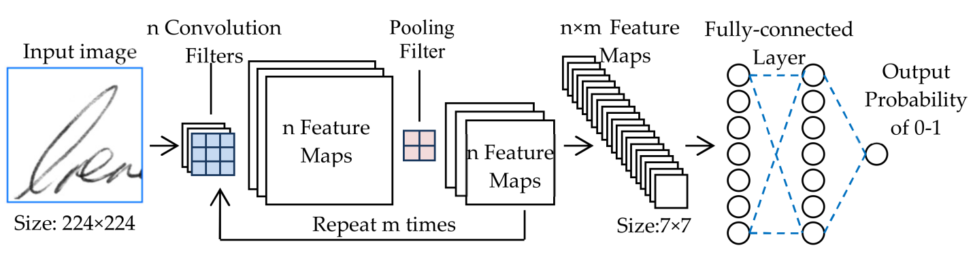
SYSTEM REQUIREMENTS:
HARDWARE REQUIREMENTS:

• System : Pentium IV 2.4 GHz.
• Hard Disk : 40 GB.
• Ram : 512 Mb.

SOFTWARE REQUIREMENTS:

• Operating system : - Windows.
• Coding Language : python.

